Cleanliness Requirement Analysis for PET Shredding and Recycling — Comparison with PP, PA, and PC Materials
(Subtitle: Technical Guidelines for Plastic Recycling and Modification Systems)

1. Introduction
In the plastic recycling and modification industry, PET (Polyethylene Terephthalate) requires a much higher level of cleanliness during shredding and recycling compared with PP and other general-purpose plastics.
The reasons are as follows:

2. Why PET Requires Higher Cleanliness
- High thermal sensitivity – PET easily degrades under heat or moisture, reducing molecular weight and transparency.
- High purity demand in applications – Used in bottles, food packaging, and optical films, PET requires consistent color and molecular structure.
- Severe impurity impact – Even <0.5% PP, PE, or PVC contamination can cause crystallization issues, yellowing, or screw clogging.
- Moisture sensitivity – PET must be dried to ≤0.005% moisture before processing to avoid bubbling and hydrolysis.

3. Comparison with Other Plastics
(See chart: Cleanliness Requirement Comparison for Shredding and Recycling — PET vs PP vs PA vs PC)
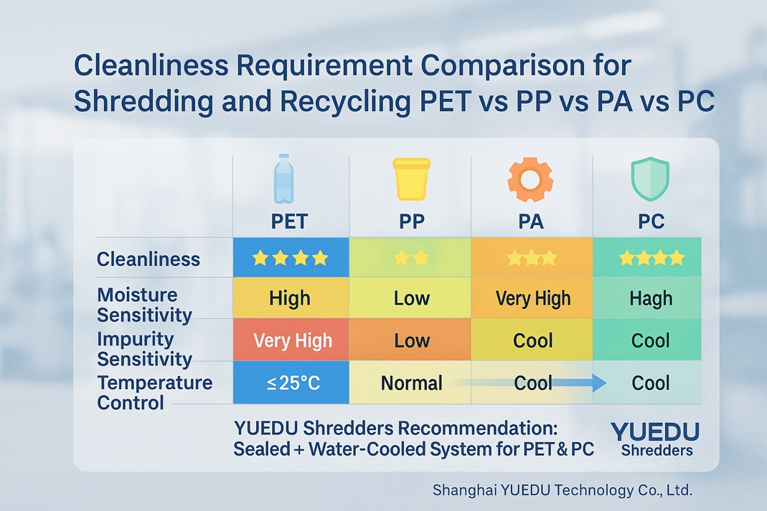
- PP (Polypropylene): Low sensitivity to impurities; easy to process; moderate cleanliness required.
- PA (Nylon / Polyamide): Moisture-sensitive; requires drying and dust removal.
- PC (Polycarbonate): Similar to PET; high clarity and cleanliness required, sensitive to temperature rise.

4. Recommended System Configuration
For high-cleanliness recycling applications, the shredding line should include:
- Sealed dust-free enclosure to prevent contamination;
- Magnetic separator to remove metallic particles;
- Water-cooled low-temperature shredding system (≤25°C);
- Static elimination & inline drying for moisture control;
- Modular design for easy cleaning and maintenance.

5. Conclusion
PET and PC are high-purity materials requiring advanced recycling systems integrating dust extraction, cooling, drying, and static control.
PP is more tolerant, while PA demands moisture management.
For such high-cleanliness applications, YUEDU Shredders provides sealed, low-temperature recycling systems widely used in PET, PC, and engineering plastics industries.

🌐 Contact Us
Shanghai YUEDU Technology Co., Ltd.
📞 Contact Us to explore more customized models and tailored shredding solutions that suit your specific needs!
Let us help you find the perfect equipment for your application.
📱 Sales Supervisor: +86 159 0178 2779 (WhatsApp / WeChat / Facebook)
📱 Administrative Supervisor: +86 137 6138 5116
📧 Email: yuedushredders@gmail.com | denghao8410@gmail.com
🌐 Website: www.yuedushredders.com
@YUEDUShredders – Empowering Global Industries with Intelligent Destruction Systems.

